Module Name: Selenium web form
Test Case ID: 7
Webpage URL: https://www.selenium.dev/selenium/web

Scenario ID: 1

Scenario: Open website
Test Steps:
1. Open the website

Screenshots: 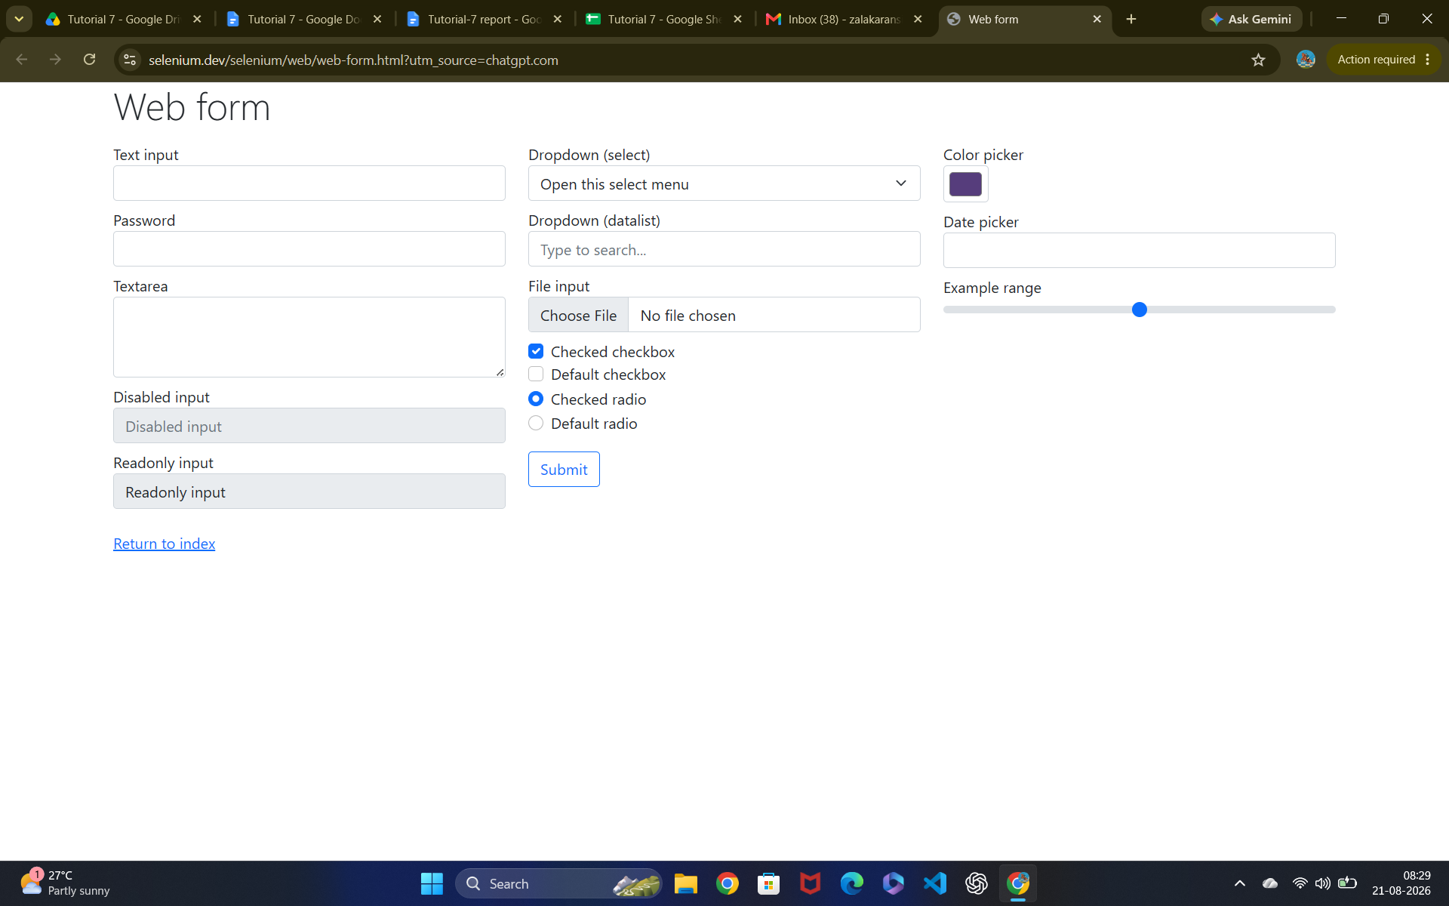Scenario ID: 2

Scenario: Enter username of below 4 characters
Test Steps:
1. Enter username of 3 characters

Screenshots: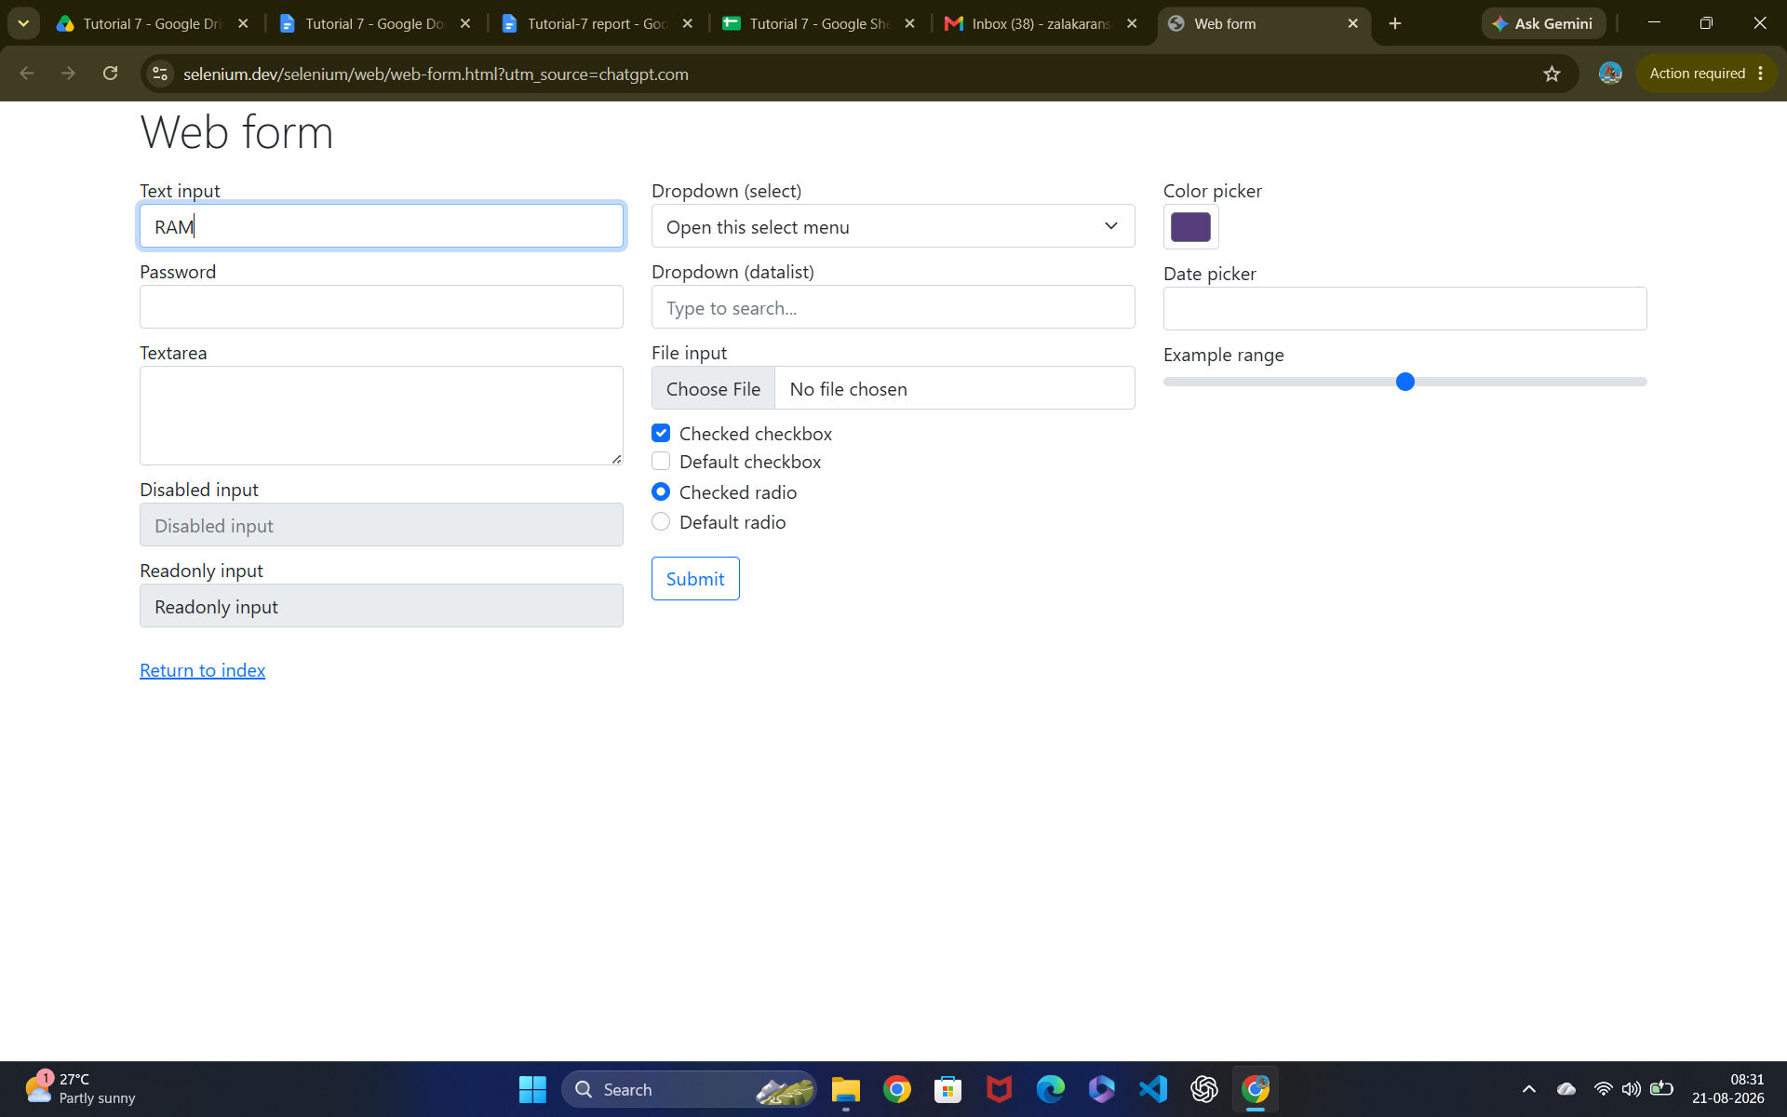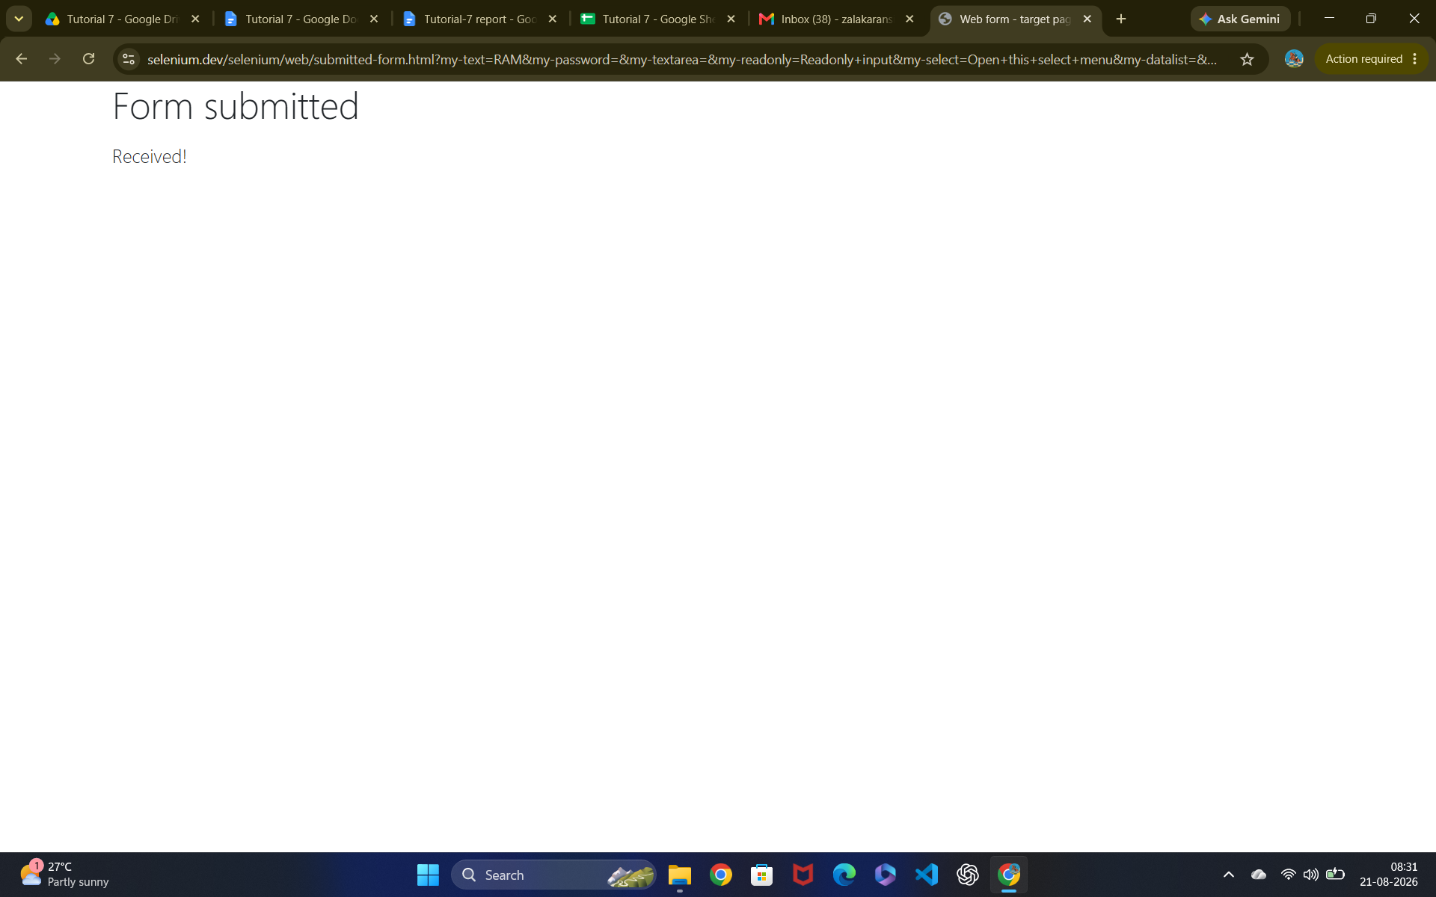Scenario ID: 3

Scenario: Enter username of 6 characters
Test Steps:
1. Enter username of 6 characters

Screenshots: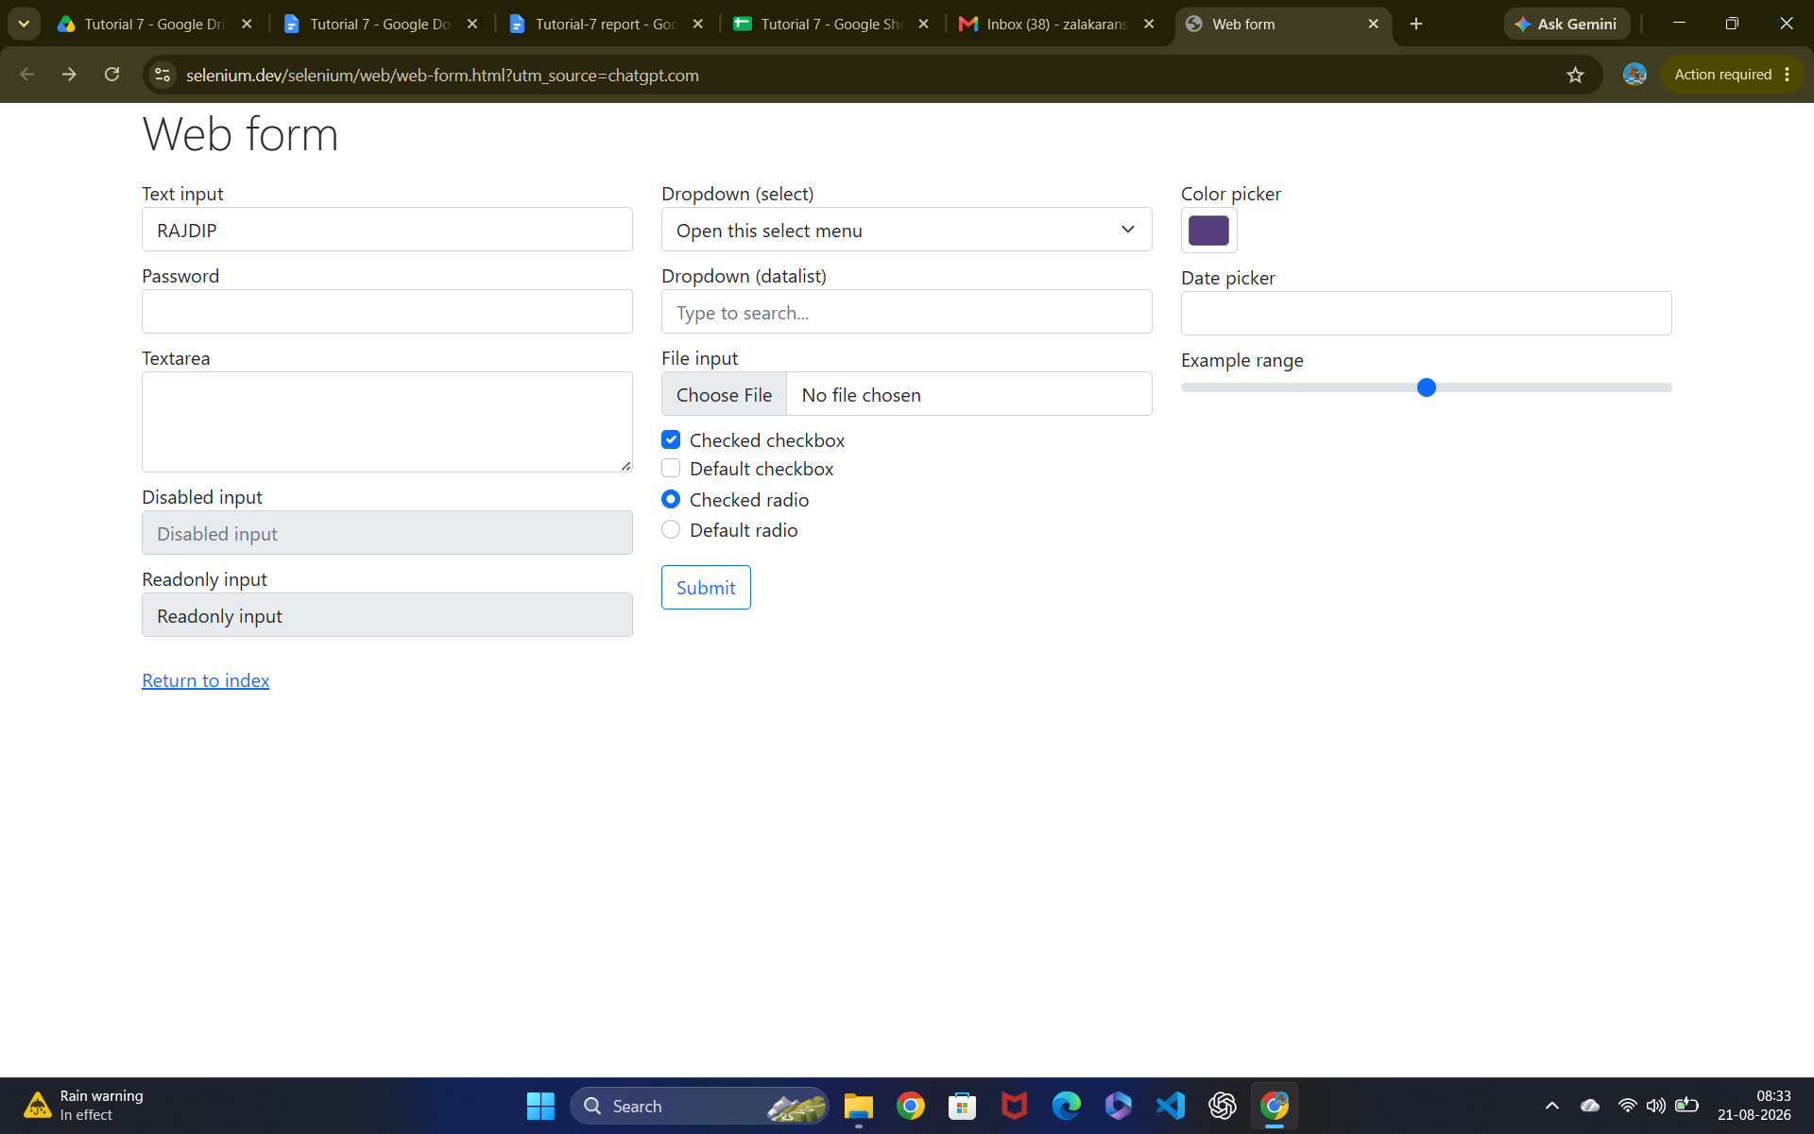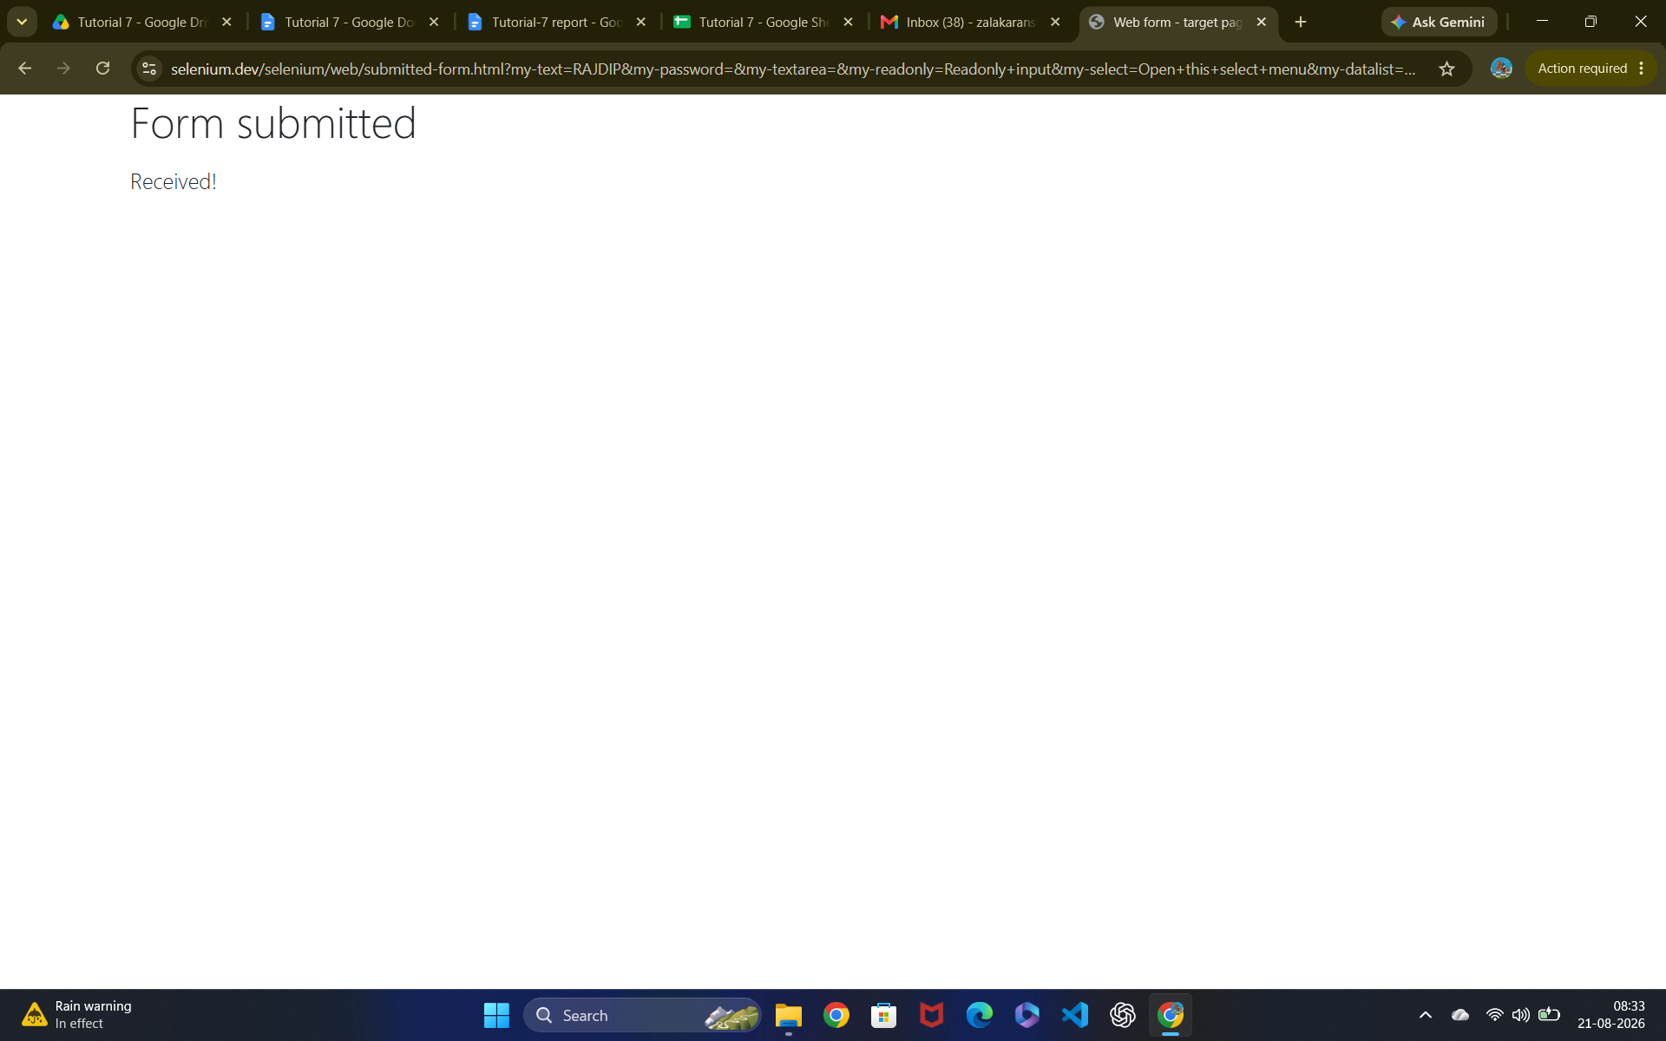
Scenario ID: 4

Scenario: Enter username of above 15 characters
Test Steps:
1. Enter username of 22 characters

Screenshots:

